Docker Notes

Introduction to Build and Package Manager Tools

1. Simple Explanation
Before you can "ship" software, you have to "pack" it. Imagine baking a cake. You
have raw ingredients (flour, eggs = source code). You need a mixer and an oven
(Build Tools) to turn those ingredients into a finished cake (Artifact). Build Tools
(like Maven for Java or npm for Node.js) automate the process of downloading
ingredients and baking the code into a runnable file.

2. Why This Matters in DevOps
You cannot deploy raw code directly to production servers. You must first compile
and package it into a stable format. Automation tools ensure that every time you
bake the cake, it tastes exactly the same, reducing errors in the deployment
pipeline.

3. Key Concepts
. Build Tool: Software that automates the creation of executable applications
from source code (e.g., Maven, Gradle, npm, pip).
. Artifact: The final output of the build process (e.g., a jar file, a .war file, or a
Docker image). This is what you actually deploy.
. Building the Code: The process of compiling code (checking for errors),
testing it and packaging it up.
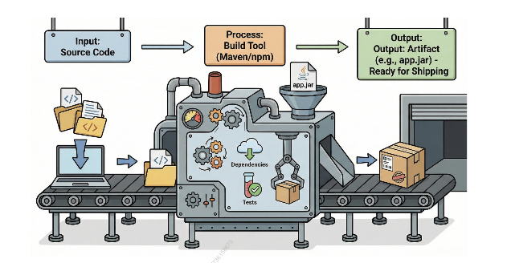
.

4. Commands / Examples
mvn package: Uses Maven to compile Java code and package it into a JAR file.

npm build: Compiles JavaScript/React applications for production.
Pip install: Installs Python dependencies required to run the code.

5. Real-World Example
A Java developer writes code. Instead of manually compiling 100 files, they run
mvn clean install. Maven gathers all necessary libraries, runs unit tests, and produces
a single myapp.jar file that the Operations team can deploy.

6. Common Beginner Mistakes
Mistake: Confusing source code with artifacts.
Correction: Source code is what you write, the artifact is the binary file that
actually, runs on the server.
7. Quick Revision Summary
- Build Tools automate compilation and packaging.
- Artifacts are the deployable outcomes (JARs, WARs).
- Examples: Maven (Java), npm (Node.js), pip (Python).
- Building ensures code is error-free and ready for release.

Introduction to Docker and Containers
1. Simple Explanation
Imagine you need to ship a house to another country. If you move the whole
house (foundations, plumbing, walls), it is heavy, expensive, and slow. This is how
Virtual Machines (VMs) work-they carry an entire Operating System (OS) with
them.
Docker is like moving into a furnished apartment. You only bring your personal
items (your application code) because the building (the host OS) already provides
the plumbing and electricity. Docker wraps your application in a Container-a
lightweight box that has everything your app needs to run, but shares the heavy
system parts with the computer it runs on.
2. Why This Matters in DevOps
In the past, code worked on a developer's laptop but failed in production because
the environments were different ("It works on my machine!" syndrome). Docker
solves this by ensuring the application runs exactly the same way in Development,
Testing, and Production, regardless of the underlying server.

3. Key Concepts
Container: A lightweight, standalone package of software that includes code,
runtime, system tools, and libraries.
Image: The "blueprint" or "template" used to create containers. An image is
read-only; a container is the running instance of that image.
Docker Engine: The core software installed on your computer that builds and
runs these containers.

4. Visual / Diagram Explanation
VM vs. Container Architecture:
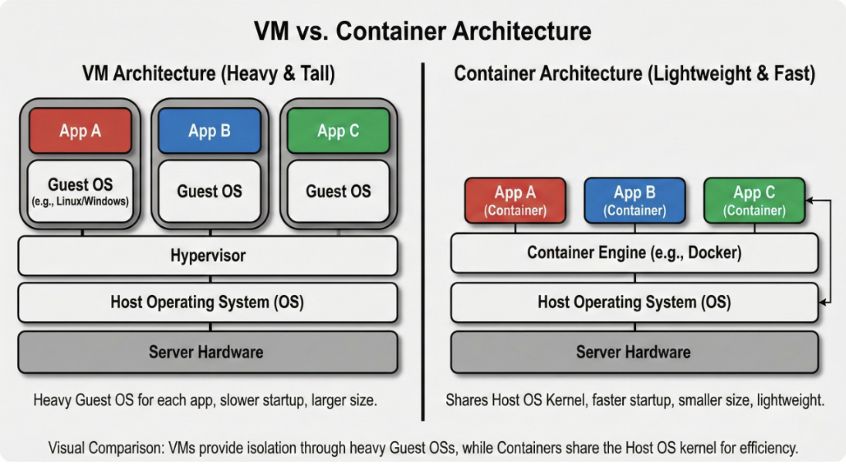
5. Real-World Example
A company like Netflix uses containers to run microservices. Instead of one giant
application, they have small containers for "Login," "Video Player," and
"Recommendations." If the "Video Player" needs an update, they just replace that
specific container without restarting the whole system.
6. Common Beginner Mistakes
Mistake: Treating a container like a full VM and trying to install a GUI or heavy
OS updates inside it.
Correction: Containers are meant to be minimal. Only install exactly what your
application needs to run.
7. Quick Revision Summary
Docker solves the "works on my machine" problem.
Image = The recipe/blueprint.
Container = The cooked meal/running instance.
Containers share the host OS kernel, making them faster than VMs.
Docker Engine is the software that powers it all.
A Dockerfile is the blueprint used to build a Docker image.
An Image is the final built package created from that Dockerfile.
Think about baking a cake 🎂
- 📖 Recipe → tells you ingredients + steps
- 🎂 Cake → the final thing you eat
Now map that to Docker:
- 📝 Dockerfile = 📖 Recipe (blueprint)
- 📦 Docker Image = 🎂 Cake (final product built from recipe)
You don’t eat the recipe… you follow it to make the cake.
Same way, Docker uses the Dockerfile instructions to build the Image.
- 🚀 Container = Slice of cake you’re actually eating
Here’s what that means:
- The Image is like a ready-made cake sitting on the table.
- When you run that image, Docker creates a Container.
- A Container is a running instance of an image.
Even simpler:
- Dockerfile → Instructions
- Image → Built package
- Container → Running application
You can create multiple containers from the same image, just like cutting multiple slices from one cake 🎂
Docker Architecture & Components
Dockerfile It’s the blueprint for creating an Image.
Docker Image – A read-only template used to create containers.
Docker Container – A running instance of an image.
1. Simple Explanation
🍽️Docker = Restaurant Kitchen Analogy
- 👤 Docker Client → The Waiter
Takes your order (commands like docker run, docker build) and sends it to the kitchen.
- 👨‍🍳 Docker Daemon → The Head Chef
Actually does the work — building images, running containers, stopping them, etc.
- 🛒 Docker Registry → The Supermarket / Pantry
Stores ingredients (Docker Images) that the chef can pull when needed.
Example: Docker Hub.
2. Why This Matters in DevOps
Understanding Docker architecture helps you troubleshoot effectively.
If you type a command and nothing happens, the issue could be:
- ❌ The Client can’t communicate with the Daemon
  - Example: Docker service not running
  - Error: Cannot connect to the Docker daemon
- ❌ The Daemon cannot reach the Registry
  - Example: No internet access
  - Firewall blocking connection
  - Docker Hub is down
Without understanding the architecture, you wouldn’t know where to check.
💡 Real DevOps Mindset
Instead of saying:
“Docker is not working.”
You think:
- Is the Docker daemon running?
- Is the client properly configured?
- Is the registry reachable?
- Is authentication failing?
That structured thinking is what makes someone strong in DevOps.
3️⃣ Key Concepts in Docker
🛠️ Docker Daemon (dockerd)
- A background service running on the host machine.
- Responsible for managing:
  - Images
  - Containers
  - Networks
  - Volumes
- It listens for Docker API requests and executes them.
👉 In simple terms: It’s the engine that does all the work.
💻 Docker Client (docker)
- The command-line tool you use.
- Sends commands to the Docker Daemon.
- Example commands:
  - docker build
  - docker run
  - docker pull
  - docker ps
👉 It’s the interface between you and Docker
📦 Docker Registry
- A storage system for Docker Images.
- Default public registry: Docker Hub
- Companies often use:
  - Private registries
  - Self-hosted registries
  - Cloud registries (like AWS ECR, Azure ACR, etc.)
👉 It’s where images are stored and shared.

4. Visual / Diagram Explanation
The Client-Server Flow:
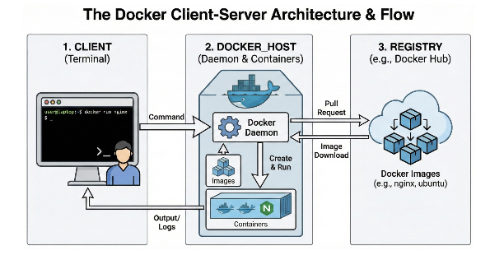
5️⃣ Commands / Examples
🔹 docker version
- Shows version information for:
  - Docker Client
  - Docker Daemon
- Helps verify if both are installed and communicating properly.
Example use case:
If Client and Daemon versions don’t match or Daemon isn’t running, you’ll see errors here.
🔹 docker info
- Displays detailed system-wide information:
  - Number of containers
  - Number of images
  - Storage driver
  - Network details
  - Registry configuration
👉 Very useful for troubleshooting and environment validation.
6️⃣ Real-World Example (CI/CD)
In a CI/CD pipeline:
- A Jenkins server acts as the Docker Client.
- It sends commands like:
  - docker build
  - docker push
- The Docker Daemon (on a build server) executes those commands.
- The built image is pushed to a private Docker Registry.
- Later, production servers pull that image and run containers.
This ensures:
- Consistent deployments
- Same image in Dev, Test, and Prod
- Immutable infrastructure

7️⃣ Common Beginner Mistakes
❌ Mistake:
Thinking Docker Client and Docker Daemon must be on the same machine.
✅ Correction:
You can configure a local Docker Client to communicate with a remote Docker Daemon (e.g., on a cloud VM).
Example:
Your laptop (Client) → AWS EC2 instance (Daemon)
This is very common in cloud environments.
8️⃣ Quick Revision Summary (Complete Version)
- 👤 Client → Sends commands
- ⚙️ Daemon → Builds images & runs containers
- 📝 Dockerfile → Blueprint for building images
- 📦 Image → A read-only template used to create containers.
- 🚀 Container → Running instance of image
- 🛒 Registry → Stores images
Docker Commands and Usage
1️⃣ Simple Explanation
Think of Docker commands like a remote control for containers 📺
You need buttons to:
- ▶ Start containers
- ⏹ Stop containers
- 🔍 Look inside them
- 🗑 Remove them
Without commands, containers are just objects.
Commands are how you control them.
2️⃣ Why This Matters in DevOps
DevOps engineers live in the terminal 💻
Mastering Docker commands allows you to:
- 🚀 Deploy applications quickly
- 🔍 Debug crashing containers
- 🔁 Automate builds in CI/CD
- 📦 Manage environments efficiently
In production, when something breaks, you don’t panic —
you inspect logs, check status, restart containers, or redeploy.
Speed + accuracy = strong DevOps engineer
3️⃣ Key Concepts
🔹 Lifecycle Commands
These manage container creation and state.
Common commands:
- docker run → Create and start a container
- docker start → Start stopped container (Start = bring back to life)
- docker stop → Gracefully stop container
- docker restart → Restart container (Restart = reboot)
- docker rm → Remove container
👉 These control the life of a container.

🔹 Inspection Commands
Used to debug and monitor containers.
Important ones:
- docker ps → List running containers
- docker ps -a → List all containers
- docker logs <container> → View logs
- docker inspect <container> → Detailed JSON info
- docker exec -it <container> bash → Access container shell
👉 These help you diagnose problems.
💡 Extra Pro Tip (Interview Level)
If a container crashes:
- Check if it’s running → docker ps -a
- Check logs → docker logs
- Inspect configuration → docker inspect
- Restart if needed → docker restart
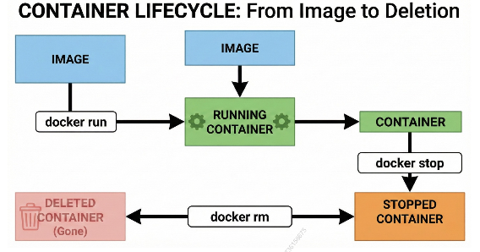
Container Lifecycle (From Image to Deletion)
🔹 Step 1: Image
An Image is the blueprint/template.
Nothing is running yet.
Step 2: docker run
When you run:
docker run -d nginx
Docker:
- Pulls the image (if not present)
- Creates a container
- Starts it
Now the container is in:
🟢 Running State
You can check it using:
docker ps
🔹 Step 3: docker stop
docker stop <container_id>
Now the container moves to:
🟠 Stopped State
The container still exists — it’s just not running.
You can see it using:
docker ps -a
🔹 Step 4: docker rm
docker rm <container_id>
Now the container is:
🔴 Deleted (Gone)
Important:
- Image still exists
- Only the container is removed

Quick Lifecycle Flow (Memorize This)
- Image
⬇
docker run
⬇
Running Container
⬇
docker stop
⬇
Stopped Container
⬇
docker rm
⬇
Deleted Container
Real-World Scenario (Production Issue)
- App stops responding
- You check running containers → docker ps
- Check logs → docker logs
- Restart → docker restart
That’s exactly how real troubleshooting works.
Common Beginner Mistake
Confusing:
- docker stop → Turns it off
- docker rm → Throws it in the trash
Beginners often think stopping a container removes it.
It does NOT.
8️⃣ Quick Revision Summary
- docker run → Create and start a container
- docker ps → List running containers
- docker logs → View container output / errors
- docker exec -it → Enter inside a running container
- docker stop → Stop (halt) a container
- docker rm → Delete a container
Dockerfile and Image Management
Simple Explanation
A Dockerfile is like a recipe card.
It lists:
- Base OS (FROM ubuntu, FROM node, etc.)
- Application code (COPY, ADD)
- Install commands (RUN apt install, npm install)
- Environment variables (ENV)
- Startup command (CMD or ENTRYPOINT)
Docker reads this file and builds a Docker Image.
- Dockerfile = Instructions
- Image = Final packaged application
2️⃣ Why This Matters in DevOps
This is true Infrastructure as Code (IaC).
Instead of manually:
- Installing dependencies
- Configuring servers
- Running setup scripts
You write everything in a Dockerfile.
Now:
- Any developer can build the same environment.
- CI/CD pipelines can build images automatically.
- No “it works on my machine” problems.
- Environments become reproducible and version-controlled.
That’s huge in DevOps.
Important DevOps Concept: Immutability
In modern DevOps:
You don’t modify running containers.
Instead:
- Update the Dockerfile
- Build a new image
- Deploy new container
- Remove old container
That’s called immutable infrastructure.
3️⃣ Key Concepts
Layers
Every instruction in a Dockerfile creates a new layer. Docker caches layers. This makes builds much faster.
Context
The build context is the set of files available to Docker during build.
4. Visual / Diagram Explanation
The Layer Cake:

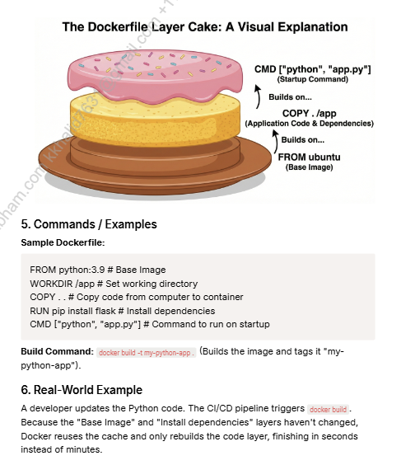

4. Visual / Diagram Explanation
Container Lifecycle:

158675

